**Project Design Phase-II**

**Data Flow Diagram**

|  |  |
| --- | --- |
| Date | 17 October 2022 |
| Team ID | PNT2022TMID20316 |
| Project Name | Project – AI-Powered Nutrition Analyzer for Fitnees Enthusiasts |
| Maximum Marks | 4 Marks |

**Data Flow Diagrams:**

A Data Flow Diagram (DFD) is a traditional visual representation of the information flows within a system. A neat and clear DFD can depict the right amount of the system requirement graphically. It shows how data enters and leaves the system, what changes the information, and where data is stored.

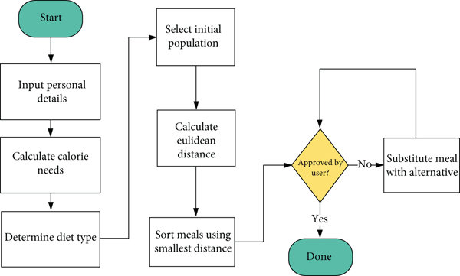

The system architecture for the Dia-betes Management System presented below in diagram is theconceptual model that defines the structure, behavioural interactions, and multiple system views that underpins the system development. It presents the formal descriptions of the systems captured graphically that supports reasoning, and the submodules developed as well as the dataflows between the developed modules. presents the components of the system archi-tecture, which comprises (1) Diabetes Intelligent Meal Recommender Module, (2)Educational Module for Dia-betics with Food Recognition Engine, (3) Activity Tracking Module, and (4) Medication Reminder Module. shows the corresponding activity flow diagram for the sub-modules developed.